INTRODUCTION
Global climate change is expected to affect all ecosystems at an accelerating pace over the next century (IPCC 2007; Caldeira and Wickett 2003). Many of the projected changes will have significant consequences for natural populations, from molecular physiological changes to broad-scale range shifts (Talmage and Gobler 2011; O’Donnell et al. 2009; Wong et al. 2011; Tomanek et al. 2011; Banks et al. 2010; Perry et al. 2005). Ocean acidification has been gaining increasing attention as one of the more insidious changes to accompany global climate change. As atmospheric anthropogenic CO₂ reaches equilibrium with ocean surface waters it dissolves and more H⁺ ions are released into the water. The increase in H⁺ ion concentration in seawater is the direct cause for decreased pH (acidification); however, other changes resulting from this same chemical reaction may also have significant effects on aquatic organisms. Increased CO₂ concentration in seawater can change the gradient between an organism’s internal fluids and its environment, resulting in a greater diffusion of CO₂ into animal tissues (Fabry et al. 2008). Increases in internal CO₂ concentrations can result in acidosis of metabolic fluids, as seen in cuttlefish Sepia officinalis (Gutowska et al. 2010), the sea urchin Psammechinus miliaris (Miles et al. 2007), and the mussel Mytulis edulis (Michaelidis et al. 2005).
Aquatic invertebrates, as environmental conformers, may be especially susceptible to changes such as ocean acidification since they may not have the physiological mechanisms necessary to counteract significant and sustained environmental shifts. In particular, acidification-induced changes can lead to inhibited calcification or shell dissolution and alterations in ion balance. The dissolution of CO₂ in seawater not only produces more H⁺, it also produces greater concentrations of bicarbonate (HCO₃⁻) and makes carbonate ion (CO₃²⁻) less available. The latter effect is of great importance to calcifying organisms since they rely on the availability of CO₃²⁻ to form and maintain carbonate-based structures (Beniash et al. 2010; Thomsen and Melzner 2010). Many aquatic invertebrates dissolve their calcified structures to make HCO₃⁻ more available as a buffer against internal acidosis caused by ocean acidification. This phenomenon has been observed across a range of shell-forming invertebrate species: the oyster Crassostrea gigas (Lannig et al. 2010), the limpet Patella vulgata (Marchant et al. 2010), and the urchin Psammechinus miliaris (Miles et al. 2007).
Stresses induced by ocean acidification can have secondary effects on organismal growth, physiology, behavior, and life history. Typically, invertebrate larvae that are reared at higher pCO₂ (partial pressure of CO₂) are smaller and have more developmental abnormalities than those at ambient pCO₂ (Chan et al. 2011; Parker et al. 2010). A host of physiological changes are also associated with changes in pCO₂. Invertebrate larvae raised at elevated pCO₂ show an inhibited ability to launch a heat shock response (O’Donnell et al. 2009) and alterations in both transciptomic and proteomic profiles (Todgham and Hofmann 2009; Wong et al. 2011; Stumpp et al. 2011). Urchin larvae (Strongylocentrotus purpuratus) reacted to ocean acidification through changes in expression of genes involved in acid-base balance, ion regulation, biomineralization and skeletogenesis, cellular stress response, metabolism, and apoptosis (Todgham and Hofmann 2009; Stumpp et al. 2011). In larval barnacles (Balanus amphitrite), Wong et al. (2011) detected changes in expression of proteins involved in respiration, energy metabolism, endocytosis, cell matrix degradation, and cellular stress. These physiological changes suggest that ocean acidification has negative and potentially long-lasting effects on invertebrate species.
Sustained environmental change, such as ocean acidification, can negatively affect both the ecosystem and economy through its effects on species such as the Pacific oyster. Oysters are ecologically important because they increase water quality through filter feeding and form reefs that create habitat for a myriad of other estuarine organisms. They are also economically important, with over 30,000 tons harvested in 2008 and contributing to a multi-million dollar aquaculture industry (FAO 2010 ftp://ftp.fao.org/FI/CDrom/CD_yearbook_2008/navigation/index_content_aquaculture_e.htm#C). Recently, in the Pacific Northwest of the U.S., there has been increasing concern over the already apparent effects of corrosive, acidified water on both natural and hatchery production of C. gigas larvae (Feely et al. 2010).
This study characterized the effects of two elevated levels of pCO₂ on size, calcification and physiology during early larval stages of the Pacific oyster, Crassostrea gigas. C. gigas larvae were raised in two elevated levels of pCO₂ (700 and 1000 µatm) and ambient (400 µatm) seawater from fertilization through four days post-fertilization. During this time, the larvae were assessed for growth, calcification, and physiological response to ocean acidification through use of gene expression assays.

METHODS
Seawater chemistry manipulation
Experimental conditions were obtained using a flow-through system that draws in seawater from Friday Harbor, WA. Once the water entered the system, it was filtered to 0.2 µm, UV sterilized, and stripped of CO₂ through membrane contactors (Membrana, Charlotte, NC, USA) under partial vacuum. The water was mixed in large coolers that contained replicate 3 L microcosms where the larval C. gigas were held. Ambient air, stripped of CO₂ by a CO₂ adsorbtion unit (Twin Tower Engineering, Broomfield, CO, USA) was used to aerate the low-CO₂ seawater within the coolers. This replaced oxygen lost through the degassing process. Cooler pH was continuously monitored by a Durafet III pH probe (Honeywell, Morristown, NJ, USA) and pure CO₂ (Praxair, Danbury, CT, USA) was added to the system by a Honeywell UDA2182 pH controller in order to hold the pH at a constant set-point.
The set-points for pH were chosen using the program CO₂SYS (Robbins et al. 2010), with an average alkalinity of 2060 µmol kg⁻¹, to meet dissolved CO₂ levels of 400, 700 or 1000 ppm in the atmosphere (Ambient, MidCO₂, and HighCO₂), which correspond to current ambient conditions and projections for mid- and end-of-century pCO₂, respectively (IPCC 2007). The water was pumped from a mixing reservoir into larval microcosms through irrigation drippers (DIG Industries, Sun Valley, CA, USA) at a rate of 1.9 L per hour. An outflow tube at the top of the microcosms fitted with 35 µm mesh allowed water to exit the microcosms while retaining larvae. The systems were equilibrated to the correct pCO₂ treatment level 48 hours prior to the start of the experiment. All seawater used for the duration of this experiment was also equilibrated to the appropriate pCO₂ level.

Oysters
Fourteen adult C. gigas, 10 females and 4 males, were collected from Argyle Creek in Friday Harbor, WA in July, 2011. Oysters were strip spawned and eggs and sperm were pooled separately (day zero). The pooled eggs (approximately 2 million) were divided equally between 18 3-inch diameter containers. The pooled sperm was diluted in ambient seawater and a small amount was added to each container of eggs. After sperm addition, the eggs were gently agitated and incubated for 15 minutes to allow for fertilization.
The six replicates of fertilized eggs were transferred to 3 L microcosms containing respective seawater pCO₂ levels at 20°C ± xx degrees. Initial densities were approximately 1 larva mL⁻¹. On days one and three post-fertilization, larvae were randomly sampled, relaxed with 7.5% MgCl₂ and fixed in 4% paraformaldehyde (PFA) buffered in filtered seawater from two microcosms from each treatment. Briefly, all larvae were filtered onto 35 µm mesh screens and washed into 50 mL tubes of seawater. Approximately 100 larvae were removed from each tube. The remaining larvae were returned to cleaned microcosms filled with new seawater. All microcosms were similarly cleaned at each sampling event. The larvae were fed Dunaliellia sp. and Isochrysis sp. at concentrations of 30,000 cells mL⁻¹ each on days 2 and 4 post-fertilization. For feeding, water flow was turned off in microcosms for two hours.
Larvae were analyzed using light microscopy for size and calcification. Using a Nikon Eclipse E600 and NIS Elements Basic Research software (Nikon, Tokyo, Japan), larval hinge length and shell height were measured at 10x magnification. Using an inverted microscope and double polarized light, larval calcification was measured at 20x magnification. Larvae were scored as calcified on day one post-fertilization if they had obvious calcification at their hinge. On day three post-fertilization, larvae were fully calcified if the polarized light reflected a “maltese cross” in the larval shell (Figure 1; LaBarbera 1974). If the cross was not apparent, then the larvae were counted as uncalcified.
On day four, two microcosms from each treatment were randomly chosen and all larvae were preserved for transcriptomics. The larvae were spun at 2,500 rpm for one minute at room temperature. The seawater was drawn off and the larvae were immediately flash frozen in liquid nitrogen.

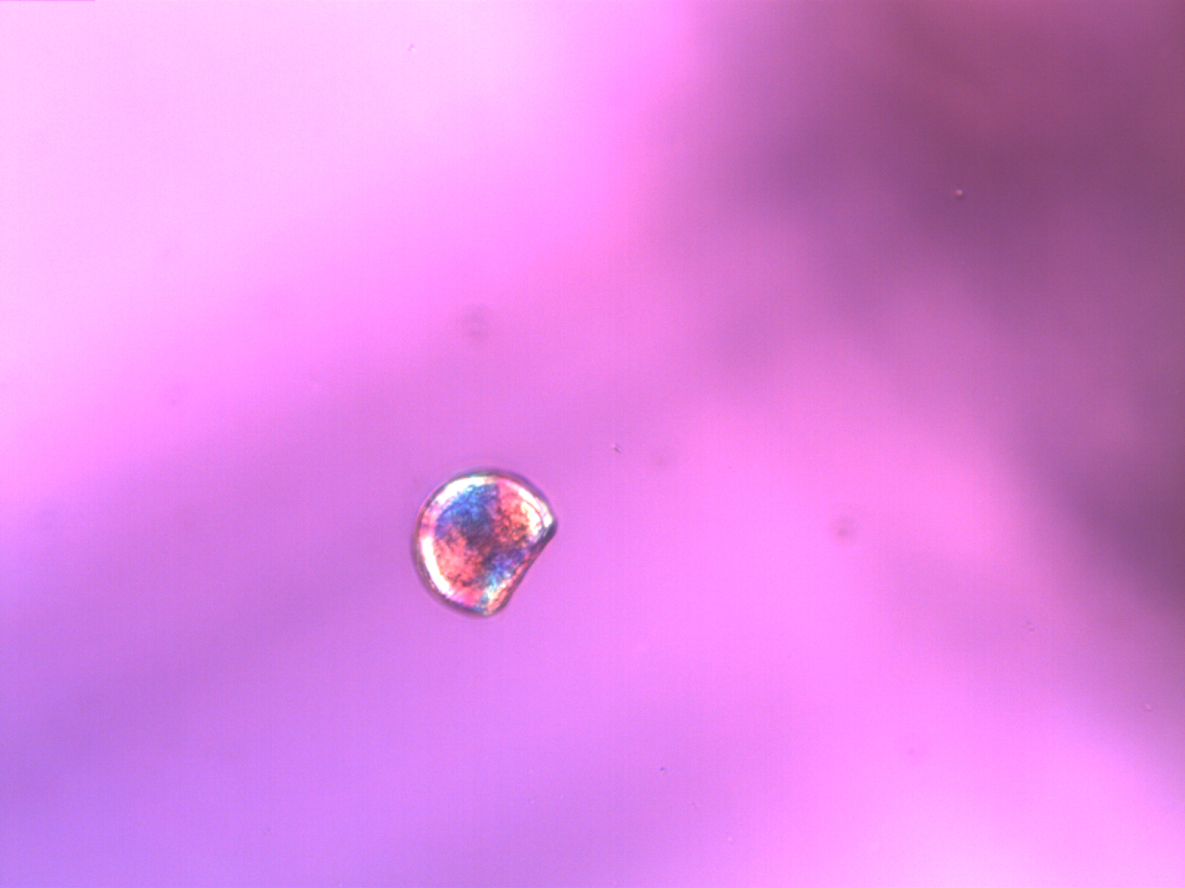
Figure 1. Fully calcified D-hinge C. gigas larva revealing a maltese cross under polarized light.

Carbonate chemistry
Throughout the experiment, salinity was measured with a conductivity meter (Hach sensION5; Loveland, CO, USA) and temperature was measured using a Fluke 1523 thermometer (Fluke, Everett, WA, USA) whenever samples were taken for carbonate chemistry. As a control, pH of the water entering the microcosms was measured daily using the spectrophotometric (spec) technique outlined in SOP 6b in Dickson et al. (2007). When the spec pH did not match the measurement from the Durafet probe, the probe was recalibrated. Measurements of pH were randomly taken from two replicate microcosms per treatment on days zero, one, and three. Final pH values reported here have been corrected for dye addition and for temperature at which the samples were taken. Total alkalinity (A_{T}) was also measured following the open cell titration of SOP 3b (Dickson et al. 2007). Samples for A_{T} were taken from the incoming water for each treatment and of 2 replicate microcosms on days zero, two, and three. Dissolved inorganic carbon (DIC) was measured in the incoming water for each treatment on days zero, two, and three by acidifying the water and passing the resultant data through a NDIR CO₂ analyzer calibrated against Certified Reference Materials from A. Dickson’s lab (Ocean Carbon Dioxide Quality Control, San Diego, CA, USA). A_{T} and pH were used to calculate calcium carbonate saturation state (Ω) of aragonite and calcite using the following constants in CO₂SYS (Robbins et al. 2010): Lueker et al. (2000) for CO₂ Constants, Dickson (1990b) for KHSO₄, Total scale (mol/kgSW) for pH scale, and Wanninkhof (1992) for Air-Sea Flux.

RNA extraction and qPCR
Total RNA was extracted from the larvae collected on day four using Tri-Reagent (Molecular Research Center, Cincinnati, OH, USA) following the manufacturer’s protocol. RNA (0.3 µg) was reverse transcribed to complementary DNA (cDNA) using M-MLV reverse transcriptase and oligo dT primers according to the manufacturer’s protocol (Promega, Madison, WI, USA). Primers were designed to amplify only cDNA by designing them to span introns of genes with known genomic structure using Primer3 (Rozen and Skaletsky 2000) in Geneious Pro v. 5.3.6 (Drummond et al. 2010). Primer sequences are in Table 1. Quantitative PCR (qPCR) was performed using 1 µL of cDNA in a 20 µL reaction containing 10 µL of 2x SsoFast Eva Green Master Mix (Bio-Rad, Hercules, CA), 8 µL of nuclease-free water, and 0.5 µL each of 10 µM forward and reverse primers (Integrated DNA Technologies, Coralville, IA, USA). Thermal cycling and fluorescence detection were performed using a CFX96 Real-Time Detection System (Bio-Rad). Cycling parameters were as follows: 98°C for 2 minutes; 40 cycles of 98°C for 2 seconds, 55°C for 5 seconds plus a plate read; melt curve from 75-95°C at 0.2°C for 10 seconds, followed by a plate read. All qPCR samples were run in duplicate.
Average Cq (fluorescence-based quantification cycle) values across replicates and average gene efficiencies were calculated with PCR Miner (Zhao and Fernald 2005, http://www.miner.ewindup.info/version2). Gene expression (R₀) was calculated based on the equation R₀ = 1/(1+E)^{Cq}, where E is the average gene efficiency and Cq is the quantification cycle for fluorescence. All expression values were normalized to expression of elongation factor 1α (GenBank Accession Number AB122066).

Statistics
Larval size was analyzed using an ANOVA with fixed effects of treatment and day, followed by Tukey’s Honestly Significant Difference test (Tukey’s HSD) when the ANOVA showed significant differences. A one-way ANOVA was also done on the larval size with the combined fixed factor of day-treatment. Larval calcification was compared between treatments using a generalized linear model (GLM). Binomial error distributions were used for all GLM analyses. GLMs assess the difference between groups while maintaining robustness to variable sample sizes. Differences in gene expression between treatments were calculated using ANOVA with treatment as a fixed effect. All analyses were performed in R (R Development Core Team 2011).

RESULTS
Carbonate chemistry
Throughout the experiment, DIC and pH were different between the three treatments, while A_{T} varied with natural fluctuations in the local water, but was stable across treatments (Table 2). A_{T} varied between 1965.59 and 2031.41 µmol kg⁻¹ (Table 2) throughout the experiment, tracking the salinity of the incoming water. The pH profiles presented in Figure 2 are from the controller logs of the Durafet pH probes. The pH values from the probes were corroborated by the spectrophotometric pH (Table 2). For the Ambient treatment (target pCO₂ of 400 ppm), the average pH was 7.99 from day zero to day four as measured by the Durafet pH probes (Figure 2). The average pH in the mid-century projection treatment (MidCO₂) was 7.75 pH units and in the end-of century projection treatment (HighCO₂) it was 7.66 pH units. DIC was highest in the HighCO₂ treatment and lowest in the Ambient (Table 2). Aragonite and calcite saturation states were greater than 1 for the duration of the experiment, except in the HighCO₂ treatment on days one and two (Table 2). Partial pressure of CO₂ in the seawater averaged 468 µatm across all five days for the Ambient treatment, 847 µatm for the MidCO₂, and 1065 µatm for the HighCO₂. Mean temperature was 20.4°C across treatments, with a minimum temperature of 19.4°C, a maximum of 21.1°C (Table 2).
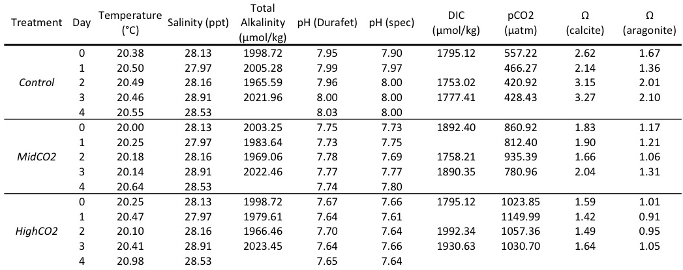
Table 2. Water chemistry data for all three treatments – Ambient, MidCO₂, and HighCO₂. Temperature and Durafet pH measurements are averages from each day based on the Honeywell controller logs. Salinity, spec pH, DIC, and A_{T} are point measurements that occurred one time each day. Partial pressure of CO₂ and Ω are calculated from spec pH and A_{T}.
Figure 2. Profiles of pH monitoring in the three different treatments – Ambient (black), MidCO₂ (light gray), and HighCO₂ (dark gray). Average pH for the experiment for each treatment is represented by solid lines. The Durafet probes took pH measurements every minute.

Size and calcification
Shell size, measured by both height and hinge length, was significantly different between days one and three and between treatments (Figures 3 and 4). The ANOVA was significant for a difference in shell hinge length across treatments (F= 8.937, p=2.93e-4) and between days (F= 1481.7, p=3.31e-5). Based on Tukey’s HSD, hinge length was significantly different in every pairwise comparison between treatments except between Ambient and MidCO₂ (Table 3). Hinge length was not significantly different between treatments on day one (p>0.8 for all), but the larvae at Ambient and at MidCO₂ were larger than those at HighCO₂ on day three (p=0.0311 and p=4.08e-5, respectively). Results were similar for shell height: MidCO₂ and Ambient were not significantly different, but both were significantly larger than HighCO₂ larvae (p>0.05, Table 3). On day one, shell height was not statistically different between treatments (p>0.5 for all comparisons), but by day three larval shell height in the HighCO₂ treatment was smaller than both the Ambient larvae (p=2.20e-6) and the MidCO₂ treatment (p=0.0311), with no difference between Ambient and MidCO₂ (p=0.565).

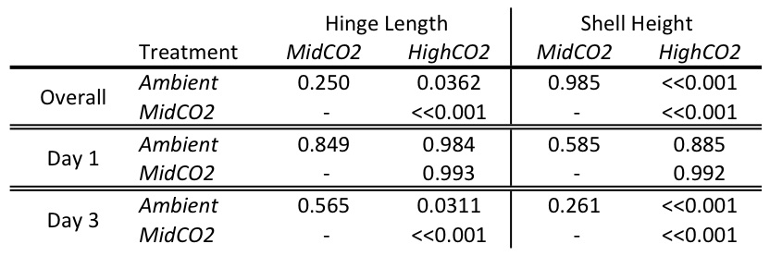
Table 3. Significance (p-values) for pairwise comparisons of shell hinge length and height from Tukey’s HSD following ANOVA. Hinge length was significantly smaller in the higher CO₂ treatments. Shell height was significantly smaller in the HighCO₂ compared to both Ambient and MidCO₂.

Larval calcification was significantly different between treatments for days one and three post-fertilization. On day one post-fertilization, calcification was greater in the HighCO₂ treatment (z-value=2.084, p=0.0372, Figure 5). On day three, the trend had switched and the larvae at HighCO₂ were significantly less calcified than the other two treatments, which had similar numbers of fully calcified larvae (z-value=-3.203, p=0.00136).

Figure 3. Larval hinge length by and day (boxplots corresponding to day one are whiate and those for day three are gray). The boxplots contain the middle 50% of the data and the bars extending from the plots encompass the data within 1.5 times the spread of the middle 50%. The open circles beyond the bars are outliers. The horizontal black bar in the plots is the median value of each data set. Larvae at HighCO₂ did not grow significantly from day one to day three and were significantly smaller than the other two treatments on day three.

Figure 4. Larval shell height by treatment and day (boxplots corresponding to day one are white and those for day three are gray). The boxplots contain the middle 50% of the data and the bars extending from the plots encompass the data within 1.5 times the spread of the middle 50%. The open circles beyond the bars are outliers. The horizontal black bar in the plots is the median value of each data set. On day three, larvae at HighCO₂ had shorter shell height than the controls raised at Ambient.
Figure 5. Proportion of larvae calcified, by treatment, at one and three days post-fertilization. The bars representing calcification on day one are white; those representing day three are gray. The proportion of larvae calcified in the Ambient treatment are the white bars, the MidCO₂ are light gray and the HighCO₂ are dark gray. There is a significant difference in calcification between treatments, with the highest proportion larvae calcified at HighCO₂ on day one and the fewest larvae calcified in the same treatment on day three.

Gene expression
Genes were expressed…somehow….stay tuned!

DISCUSSION

C. gigas larvae are able to tolerate moderate acidification in early development, but the impacts of exposure to more extreme acidification can be seen in their growth and physiological processes. A pCO₂ of 847+/- 67 µatm (MidCO₂) did not affect growth or calcification of larval oysters when compared to Ambient pCO₂ of 468 +/- 63 µatm. However, under an additional 200 µatm of pCO₂ (HighCO₂, 1065 +/- 58 µatm), larvae were both significantly smaller and less calcified by day three post-fertilization. These results imply that larval C. gigas are able to tolerate ocean acidification to a degree, but their physiological plasticity is overwhelmed at this developmental stage between the Mid- and HighCO₂ treatments. The calcium carbonate saturation state was also considerably different at the HighCO₂ treatment and this carbonate chemistry alteration may have played a significant role in the decreased size and calcification of the oysters. The chemistry scenarios simulated in this study are based on projections for the coming century, but these values of low pH and Ω are already occurring with increasing frequency in the nearshore waters of the Pacific Northwest (CITE), which is habitat to C. gigas and many similar species. The results from this study indicate that exposure to high pCO₂/low Ω waters in early development have the potential to significantly alter growth and calcification of C. gigas.
Increasing attention is being put on the importance of changes in carbonate saturation state (Ω) and how it affects larval growth and development. C. gigas larval survival in the hatchery is impacted by decreased Ω (calcite or aragonite? - Barton et al. in review). Growth is also inhibited under lower Ω, although not affected by lower pH (Gazeau et al. 2011). In this study, the Ω of both calcite and aragonite was never greater than 2 and Ω of aragonite (the polymorph of CaCO3 that is used the most in larval shells at his stage) was at or below 1.
Ocean acidification poses a significant current and future threat to populations of C. gigas. The results from this and a number of other studies indicate that larval C. gigas are unable to grow normally and calcify in high CO₂ environments (CITE). The root cause of the observed altered phenotype under the HighCO₂ treatment is most likely an altered energy budget (Stumpp et al. 2011). As the larvae develop in an environment that is intrinsically hostile to a variety of physiological processes, they have less energy available to grow at a normal rate and are unable to achieve full calcification. Growth and calcification are further stymied by decreased Ω, especially at the early larval stages. Within the first 24 hours post-fertilization, C. gigas appears to calcify at a greater rate under the highest pCO₂. This anomaly may be an attempt by the larvae to protect themselves against an adverse environment. When the environmental stress proves to be permanent and not transient, the larvae can no longer maintain the excess energy investment and their growth and calcification falls behind those of the larvae raised at lower pCO₂ levels.
The smaller size of the larvae at higher pCO₂ could lead to further disadvantages when compared to their counterparts at Ambient pCO₂. Smaller veliger larvae are not able to feed as efficiently as larger ones (Strathmann xxx). The inability to acquire as much food compounds the effects of ocean acidification, potentially further stunting larval growth. Additionally, selection imposed by ocean acidification at early stages of larval development could impact later stages of growth, survival and reproduction (CITE).
Species like C. gigas may have an advantage when facing climate change such as ocean acidification since their mode of reproduction results in a wide range of phenotypes in each generation. Broadcast spawning has the potential to increase the diversity of larval phenotypes that are produced in one generation, thus increasing the chances that some larvae will tolerate any adverse environmental conditions they encounter. This leads to the phenomenon known as sweepstakes selection (Hedgecock). In sweepstakes selection, many parents contribute to the initial gene pool of a generation, but only a small percentage of those parental genotypes end up persisting, mainly due to selection from a heterogeneous environment. If genotypes that are resistant to the effects of ocean acidification exist in wild populations, then there is the possibility for selection for these genotypes, leading to their enrichment in a population over time. Further research should focus on the potential not just for genotype-dependent survival of invertebrates under ocean acidification scenarios, but also genotype-dependent robustness of growth and development.

Random information:
Ocean acidification also changes ion balances across membranes, leading to an increased energy demand in organisms as they correct the imbalance or as they launch a stress response in reaction to it. Changes in ionic concentration due to hypercapnia and carbonate structure dissolution can result in overall shifts in cellular ion gradients, which could significantly alter cellular processes (Dissanayake et al. 2010). Overall, changes in environmental and internal organismal carbonate chemistry create a more stressful and energetically demanding environment for aquatic invertebrates.

Ocean acidification is a current and future challenge and will continue to negatively impact aquatic organisms. These impacts are of both ecological and economic concern since the effects of ocean acidification are seen across taxonomic groups (i.e. on an ecosystem-level scale) and have the potential to decrease the viability of commercially important populations.

Literature Cited
Perry, A.L., P.J. Low, J.R. Ellis and J.D. Reynolds. 2005. Climate change and distribution shifts in marine fishes. Science. 308:1912-1915.

